**Feasibility Report**

**For**

**Passport Verification System using Block-Chain**

**Version 2.0**

**Prepared by**

**Group No.: 04**

Group Members:

|  |  |  |
| --- | --- | --- |
| 1. Dipak Sarker Dipu | 201714021 | [dipu.mist@gmail.com](mailto:dipu.mist@gmail.com) |
| 2. Md. Ishak | 201714031 | [ishak.mist@gmail.com](mailto:ishak.mist@gmail.com) |
| 3. Rafin Lameya | 201714047 | [rafin.mist@gmail.com](mailto:rafin.mist@gmail.com) |
| 4. Tahasin Mahmud | 201714061 | [tahasin.mist@gmail.com](mailto:tahasin.mist@gmail.com) |
| 5. Tahmid Hasan Sakib | 201714062 | [thsakib.mist@gmail.com](mailto:thsakib.mist@gmail.com) |
| 6. Ismile Hossain | 201514027 | [ismile.mist@gmail.com](mailto:ismile.mist@gmail.com) |

|  |  |
| --- | --- |
| Submitted To: | **Lt. Col. Nazrul Islam, Lec Tarannum Zaki, Lec Shahrima Jannat Oishwee** |
| Course Title: | **System Analysis Design and Development** |
| Course Code: | CSE-402 |
| Date of Submission: | 03/04/2020 |

TABLE OF CONTENTS

Revisions II

Abstract/executive summary iii

1 Introduction 1

2 existing system 2

2.1 Information Gathering and Analysis 2

2.1.1 Overview & Objectives……………………………………………………………… 2

2.1.2 Information Required for System Analysis………………………………………3

2.1.3 The Sources of Information…………………………………………………………4

2.1.4 Information Gathering Methodology…………………………………………… 5

2.2 Presenting the Existing System 5

3 proposed candidate systems 7

3.1 Potential Candidate Systems 7

3.2 Characteristic of the Candidate Systems 9

3.3 Performance and Cost-effectiveness of the Candidate systems 10

3.4 Selection of the Best Candidate System……..………………………………………………….13

4 specification of the selected candidate system 14

5 conclusions 20

appendices

Appendix A – references 21

**Appendix B - questionnaire Sheets…………………………………………………….……………………..22**

Revisions

|  |  |  |  |
| --- | --- | --- | --- |
| **Version** | **Primary Author(s)** | **Description of Version** | **Date Completed** |
| Version Zero | Group-04 | Discussion about The proposed features and selected one | 11 Feb,2020 |
| Feasibility Study Version:0.1 | Group-04 | * Introduction about Block Chain * Background of Passport Verification System * Flow diagram of existing systems(Airport Passport Verification System) * Proposed candidate system * Characteristic of proposed candidate system * Qualitative matrix for candidate system * Candidate system selection   In qualitative matrix there is no weighting factor and score which has updated in this version. | 25 Feb,2020 |

ABSTRACT/EXECUTIVE SUMMARY

A passport is a document, issued by a national Government. This certifies, for the purpose of international travel, the identity and nationality of its holder. The Elements of identity are name, date-of-birth, sex and place of birth most often, most often nationality and citizenship are congruent. A passport does not of itself entitle the passport holder entry into another country, nor to consular protection while abroad or any other privileges it does. However normally entitle the passport holder to return to his country that issued the passport. Rights to consular protection arise from international agreements, and the right to return arises from the laws of the issuing country. An individual can register for a passport irrespective of his/her age. The registration of a passport is a major step for issuing a passport. It is a system or process in which an individual has to provide exact details of his /her personal information and residential information. Proper registration of a passport is very vital as all the details filled by the individual are depicted on the passport that is issued.

# 

# **1. Introduction**

Passport or Visas are one among the identification documents that are viewed as sound and astonishing. They are considered as the most credible and high-quality travel and recognizable proof report across the globe. Any individual who has experienced the way towards applying for the international ID – passports or visas, realizes how uncompromising the whole scenario is. The Procedures run down

to a strict application process that requires a scope of supporting documentation, for example, a birth testament and confirmation of citizenship. It is no big surprise that lawbreakers charge a high cost for passport frauds. Today counterfeit visas have been connected to secret shady activities like smuggling, drugs, frauds, and scope of other criminal exercises. It is a matter of great concern. As it is very difficult to identify the fake from real. The increasing rate of phony or the fake passports, keep on troubling the government in one or other way.

It is witnessed that the government and the verification bodies of various nations have tremendously failed in identifying the real passports and verifying them in a short time. Under the normal set up, it remains quite challenging to distinguish the counterfeit passports from the real ones.

However, with the introduction of block chain technology, the fear of immutable records is ruled out. Document verification under block chain has proved itself with a lot of significations like immutable records, supreme security, cheaper transactions, action traceability, proof of ownership, proof of integrity and more. In nutshell, the document verification process that uses block chain innovation and smart contracts will simply enable the government and other designated authorities to confirm that the identification you are taking is valid and credible

# **2. EXISTING SYSTEMS**

* 1. **INFORMATION GATHERING AND ANALYSIS**

**2.1.1 Overview and Objectives**

For passport verification, the present address of the passenger must be under the same Metropolitan/District police jurisdiction as the present, permanent or emergency contact address mentioned in the passenger's passport. In case of a foreign passport holder, present address means the address where she/he lived during his/her stay in Bangladesh. In case the passenger's passport does not contain any address, the passenger's present address must be supported by National ID Card, Birth ID Card or local Ward councilor certificate has to be attested by Class one gazetted officer. A foreign passport holder, residing abroad, seeking police clearance from Bangladesh must get his/her passport attested by a Justice of Peace in his/her country of residence to upload with the application. Bangladeshi nationals applying from abroad must get his/her passport attested by Bangladesh High Commission of his/her present country of residence and upload with the application. A foreign passport holder, residing abroad, seeking police clearance from Bangladesh must get his/her passport attested by a justice

of Peace in his/her country of residence and upload with the application. Police Clearance is issued through this system to only Bangladeshi nationals going or residing abroad and foreign nationals returned abroad after their stay in Bangladesh. Police Clearance required for employment or other purposes within Bangladesh are requested to contact concerned District or City Special Branch.

The reason behind framing of every rules, regulations, laws, is provocative unlawful, unruly behaviour of the public itself and this doesn't mean that any democratic government intends to force its superlative wish of authority on its public. The rule for police verification before issuing any passport is working on the same criteria. It only intends to thwart the efforts of any unruly, unlawful person to go out of the country on the basis of the passport issued to him/her and definitely this intention is achieved in most of the cases by imposing the necessity of the police verification. There may be fewer examples of wrongly issued passport which proves that the concerned passport/police officials were either misled by providing unauthentic information/documents or by bribing the officers of both these departments.

**2.1.2 Information Required for System Analysis**

**Review of Existing Literature:**

* A recent survey conducted by Transparency International Bangladesh (TIB) found that three out of four new passport seekers had to pay speed money to get clearances.
* These include police verification and attestation of documents.
* The survey conducted from September 2016 to May, 2017 concludes that more than half of passport seekers have fallen victim to various types of irregularities, harassment and corruption.
* Although the latest survey, the percentage of victims have fallen from 77.7 percent to 76.2 percent from one conducted in 2015, the fact is that things have not really improved all that much.
* Although there have been demands to end police verification altogether, we need some sort of verification nonetheless. But it must be ensured also that ordinary citizens can avail this basic document without being forced to pay bribe to law enforcers or brokers for that matter

**Documents Reviewed During Feasibility Research:**

|  |  |
| --- | --- |
| **Document** | **Summary** |
| The Daily Star Report about passport verification. | System structure and system elaborately discussed. |
| Wikipedia | Detailed discussion about the passport verification process. |
| Police clearance website | Detailed explanation of policy of police to verify the passport. |

**2.1.3 Source of gathering information**

**How does it work:**

Our Customer just needs to place their passport onto the passport scanner, which then inspects the photo of their face alongside performing numerous other checks, before returning a result that you can trust with confidence.

Our passport verification system combines state-of-the-art image processing, algorithms and an encyclopedic knowledge of passports to verify whether a passport is authentic or not.

Using 3 different types of light to scan white, infrared and ultraviolet, the passport verification system extracts data via optimal character recognition which is then harmonized with our vast datasets. The authority can review all the details of the scan, including the tests that were run, those that passed and those that failed. Facial recognition is used to incorporate in the process for an extra layer of authentication. A passport verification system can provide instant validation of facial features between a printed document face and a live facial image captured on a smart phone, tablet or webcam.

We use Optimal Character Recognition and 3 different types of light to scan ID and extract data:

* **White**: this is what our eyes see. Using white light, we can extract data, the portrait picture, and check for tampering
* **Infrared**: this will read the sub-layer of the document, not visible to the naked eye. This scan will identify any tampering or forgery
* **Ultraviolet**: this scan will extract the ultraviolet pattern, not visible to the naked eye.

**Where does it work:**

Hardware passport verification:

A passport verification system is ideal for use in airport and within a number of industries, particularly banking or telecoms, where providing someone’s identity is critical to protect a organization. In hardware a passport verification scanner is used and performs as a standalone solution.

Online passport verification:

In an online business customer can upload their passport for quick and easy online verification. Smart phone is used to as passport verification system.

**2.1.4 Information Gathering Methodology**

Here we used 3 of the 5 traditional methods of information gathering

1) Questionnaires

2) Literature Review

3) Study of existing organizational documents, forms and reports.

* 1. **PRESENTING THE EXISTING SYSTEM**

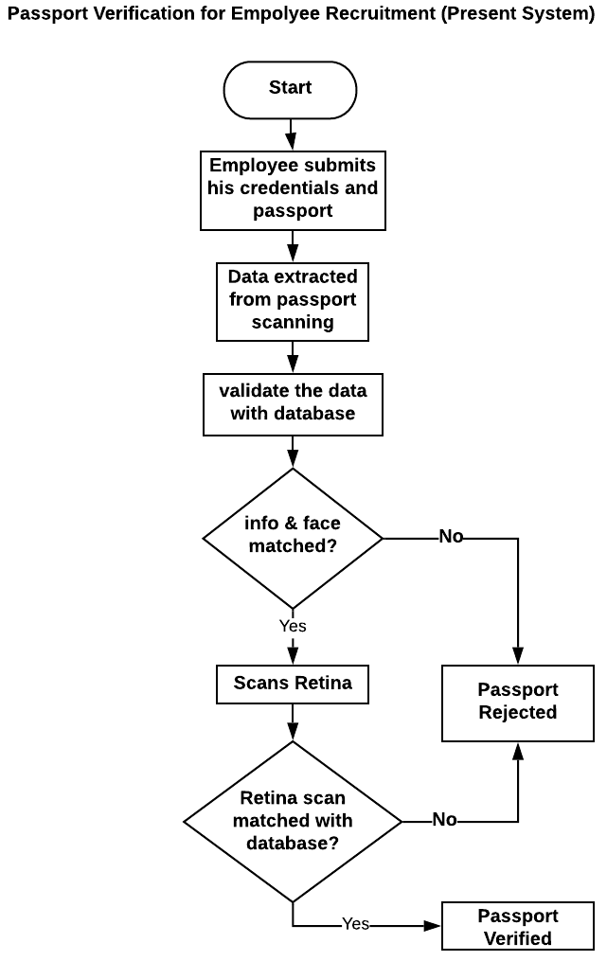

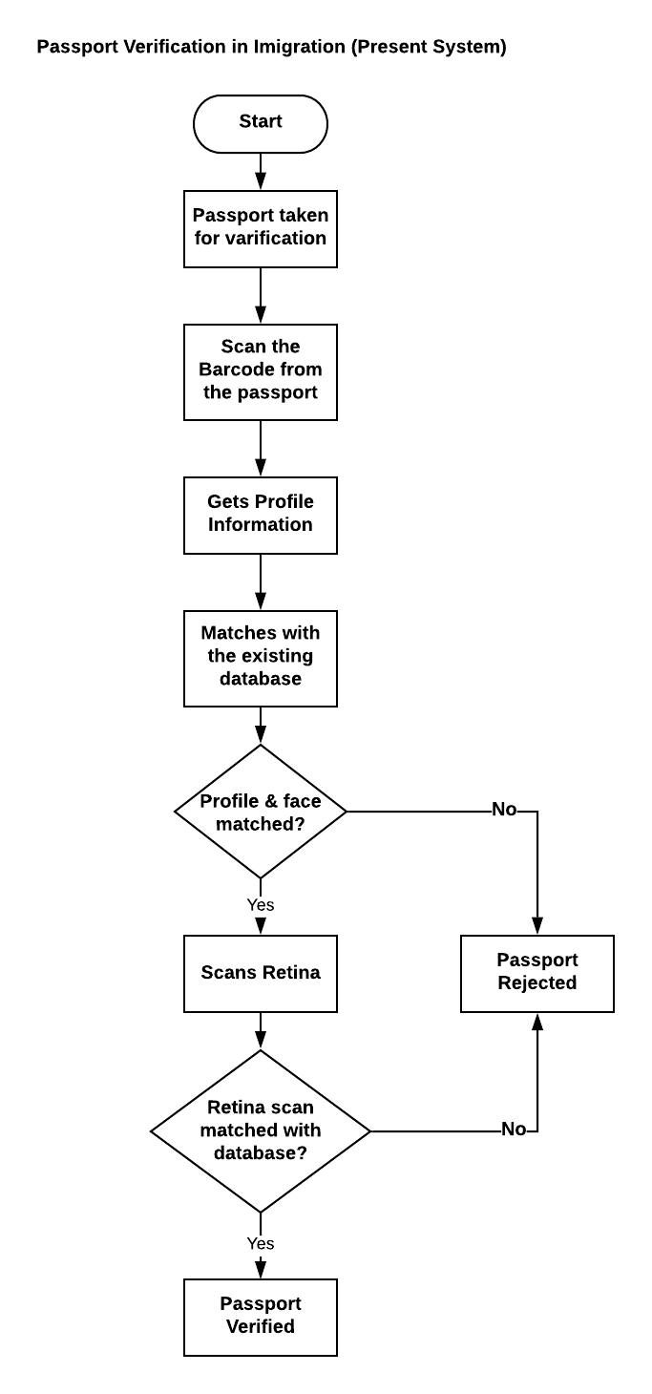

# **3. Proposed Candidate Systems**

**3.1 POTENTIAL CANDIDATE SYSTEMS**

Initially we are proposing 2 candidate systems-

1. Block Chain Based Passport Verification System

2) Fog and Cloud Based Passport Verification System.

|  |  |  |  |  |
| --- | --- | --- | --- | --- |
| **Candidate System** | **Hardware Requirements** | **Software Requirements** | **Process Flow** | **Features** |
| Block Chain Based  PV | (1)Personal Computer  (2)QR code generator | 1. QR code reading app 2. Hash Generator 3. Block Chain Network 4. Secure Database 5. Android app | (1)There will be a unique QR code and places the QR code inside of the passport  (2)A unique hash value will be generated for the passport and places this on the block chain  (3)We will populate a database with the unique hash value, block chain transaction record and URL of the PDF (to preview the passport original) | (1) Decentralized  (2)Data Transparent  (3)Open source  (4)Can not be updated without the permission of all nodes  (5)Immutable |
| **Candidate System** | **Hardware Requirements** | **Software Requirements** | **Process Flow** | **Features** |
| Fog  and  Cloud Based  PV | 1. Personal Computer 2. Storage | 1. Cloud Server. 2. Network Server 3. RFID card reader | (1)It is a decentralized cloud computing infrastructure which facilitates computing, networking and storage of data on cloud. Being an extension of cloud computing, which allows us to compute, store and network services between the fogs or the nodes. Here, most of the data-processing takes place on a smart device. | (1)Decentralized cloud computing infrastructure.  (2)Compute, store and network services between the fogs or the nodes.  (3) Most of the data-processing takes place on a smart device. |

**3.2 CHARACTERISTICS OF THE CANDIDATE SYSTEMS**

|  |  |  |
| --- | --- | --- |
| **Components** | **Block Chain PV** | **Cloud based PV** |
| Android app | Required | Not Required |
| Source language | Python | Command |
| Hash Value | Required | Not Required |
| RFID card reader | Not required | Required |
| Block chain required | Yes | No |
| User Friendly | Yes | Yes |
| Cost of System Operation | Cheap | Moderate |
| Security | Very hard to hack | Less hard to hack |
| Storage type | Decentralized | Decentralized |
| Reliability | Much reliable | Less reliable |
| Performance | Better | Average |
| Complexity | Low | High |

### **3.3 Performance and Cost-Effectiveness of the Candidate Systems**

**Table- Qualitative Matrix for the Proposed Candidate Systems**

|  |  |  |
| --- | --- | --- |
| **Evaluation criteria** | **Block Chain based PV** | **Cloud Based PV** |
| **Performance** | | |
| Performance Capacity | Excellent | Best |
| Manual Involvement | Very Good | Very Good |
| Accuracy | Good | Good |
| System Operation | Excellent | Good |
| Time Taken | Good | Good |
| Evolve Ability | Excellent | Better |
| Feedback | Good | Good |
| User Friendly | Yes | Yes |
| **Costs** | | |
| Cost of System Development | Less Expensive | Expensive |
| Cost of User Testing | Less Expensive | Expensive |
| Cost of system operation | Optimal | Minimal |
| Profit | High | Low |

**Table- Quantitative Requirements for the Proposed Systems**

|  |  |  |
| --- | --- | --- |
| **Evaluation criteria** | **Block Chain based PV** | **Cloud Based PV** |
| **Performance** | | |
| Performance Capacity | 90% | 80% |
| Manual Involvement | 80% | 80% |
| Accuracy | 90% | 85% |
| Time Taken | 75% | 70% |
| System Operation | 85% | 80% |
| Evolve Ability | 90% | 80% |
| Feedback | 80% | 80% |
| User Friendly | 80% | 80% |
| **Costs** | | |
| Cost of System Development | 50% | 60% |
| Cost of User Testing | 40% | 50% |
| Cost of system operation | 60% | 70% |
| Profit | 70% | 50% |

**Table- Weighted Matrix for the Proposed Systems**

|  |  |  |  |  |  |
| --- | --- | --- | --- | --- | --- |
| **Evaluation criteria** | **Weighting factor** | **Block Chain based PV rating** | **Block Chain based PV rating** | **Cloud Based**  **PV Rating** | **Cloud Based**  **PV** |
| **Performance** | | | | | |
| Performance capacity | 5 | 5 | 25 | 4 | 20 |
| Manual involvement | 3 | 3 | 9 | 3 | 9 |
| Accuracy | 4 | 4 | 16 | 3 | 12 |
| Time taken | 3 | 3 | 12 | 3 | 12 |
| System Operation | 5 | 5 | 20 | 4 | 15 |
| User friendly | 4 | 5 | 20 | 4 | 15 |
| Evolve Ability | 3 | 4 | 12 | 4 | 10 |
| Feedback | 3 | 3 | 14 | 3 | 12 |
| **Costs** | | | | | |
| Profit | 4 | 4 | 15 | 3 | 12 |
| Cost of system development | 5 | 3 | 15 | 2 | 10 |
| Cost of user training | 3 | 2 | 12 | 3 | 9 |
| Cost of system operation | 3 | 4 | 9 | 2 | 6 |
|  |  |  | 154 |  | 122 |

### **3.4 Selection of the Best Candidate Systems**

Among the two candidate systems we have selected the passport verification using block chain technology. And also block chain is more efficient then cloud based.

The reasons are specified below:

(1) It gives better performance compare to the 2nd system.

(2) It eliminates the dependability in other system at a great margin.

(3) It is more accurate than the 2nd candidate system

(4) It gives much more independence to the developer.

(5) Have almost no hassle with hardware.

(6) Creates a more user-friendly environment.

(7) Gives easy communication with the local authorities.

(8) User feedback is more positive than the other.

(9) It has taken less time than the other system

(10) It reduces operational costs.

# **4. Specification of the Selected Candidate Systems**

Here after much considerations and analysis we have chosen Block Chain based Passport Verification as our preferred candidate system. The specifications are given below-

**Functional requirements**

1. A unique QR code will be placed inside the passport.
2. A pdf will be generated from the new document stores this on the client secured server.
3. is not controlled by a central authority, which also enables identity

and record integration in global scale

1. The hashed number should be created using one way hashing technique.
2. Open source: most Block chain system is open to everyone, record can be check publicly and people can also use Block chain technologies to create any

applications they want.

1. Block chain database can be updated if and only if it matches all the previous changes with the local database.

**Non-Functional requirements**

1. Transparent: data record by Block chain system

is transparent to each node, each of these nodes can further update the data as well which makes it trustworthy

1. The cost of block chain based system is less
2. Immutable: Any records will be reserved forever, and can’t be changed unless someone who has control more than 51% nodes at the same time.
3. It’s security is hard to break only can be broken if private key is hacked
4. Throughput of the block chain system is high.

**Data Flow Diagram of Block Chain Based Passport Verification Sytem**

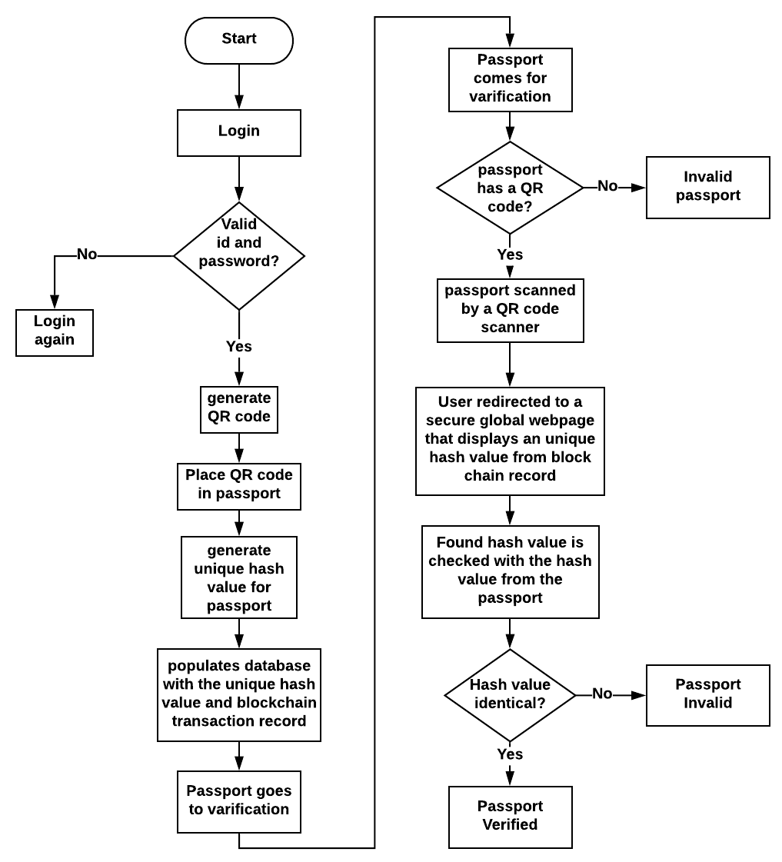

**Decision tree**

Decision Tree - l

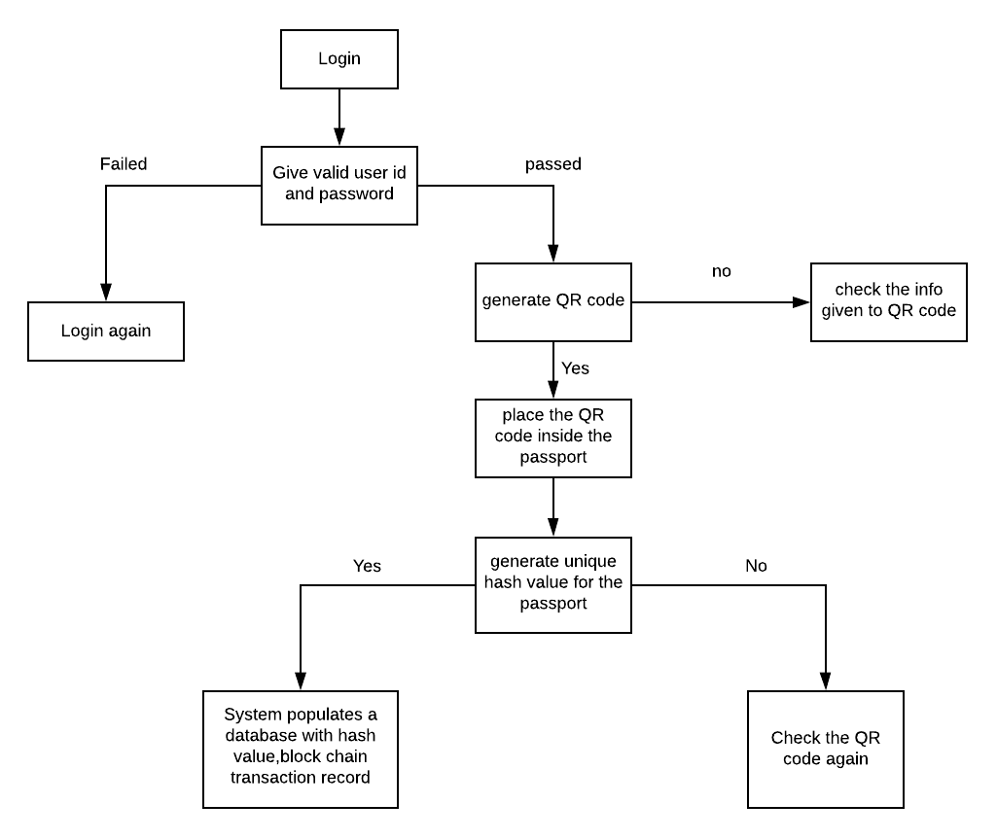

Decision tree – ll

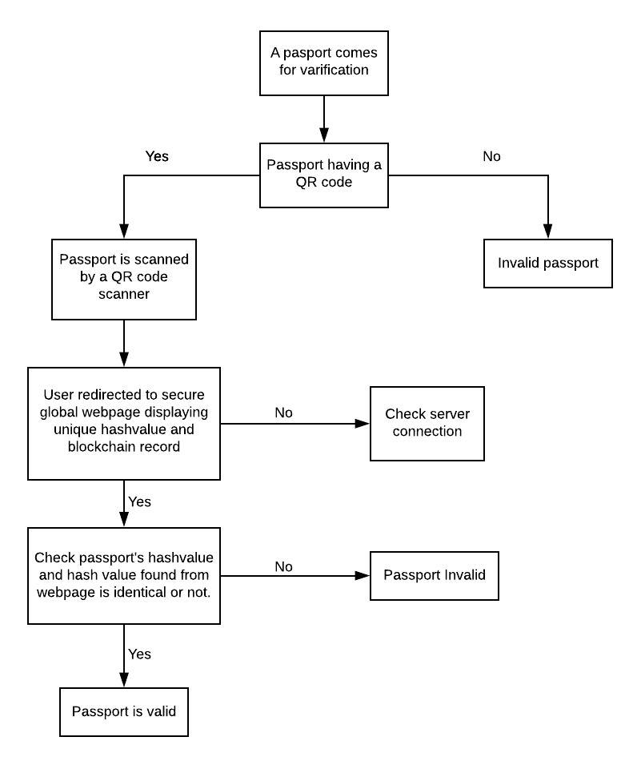

**Decision table**

|  |  |  |  |  |  |
| --- | --- | --- | --- | --- | --- |
| Billing | 1 | 2 | 3 | 4 | 5 |
| login succeeded?  Is qr code generated?  If Is hash value generated?  Is hash value identical? | N  -  -  - | Y  Y  N  - | Y  -  -  N | Y  -  -  Y | Y  -  -  N |
| Passport scanned?  then Data send to database?  Match with the hash value?  Passport verified? | X  -  -  -  - | -  -  -  X  - | -  -  -  -  X | -  -  -  X  - | -  -  X  -  - |

**Structured English**

IF login successful THEN

Give valid profile information

Generate a QR code

IF QR code generated THEN

Place the QR code inside the passport

Generate Hash value

IF hash value acquired THEN

Populates database with the unique hash value and block chain transaction record

Passport goes for verification

ELSE

Check QR code again

END IF

ELSE

Check Information again to generate QR code

END IF

ELSE

Try with right id and password again

END IF

Passport comes for verification

IF passport has a QR code THEN

Passport scanned by a QR code scanner

Redirected to a secure global webpage that displays a unique hash value form block chain record

Found hash value is matched with the hash value from the passport

IF hash values are identical THEN

Passport is declared VALID

ELSE

Passport is declared INVALID

END IF

ELSE

Passport is declared INVALID

END IF

EXIT

**Economic justification**

1)Less manpower is needed so less expensive.

2) Our system does not require much hardware which reduces the cost.

3)Our android app system uses less resources.

4)Hash value is generated so that security maintenance is cheap.

# **Conclusions**

Passport verification in Block chain Passports or Visas facilitate safe movements across nations. Be that as it may, in 2016, the loss of almost 20,000 international IDs were accounted for. Such episodes lead to a rising alarm in wrongdoings like data fraud. Also, manual identification checks are wasteful, and it can cause delays in airports and borders.

The system which is selected through the analysis stages is comparatively cheap and efficient. Here the security system depends on hashing technique and authorities actions which reduces the cost significantly compared to the other existing system.

This challenge will be more stretched with the expanding number of voyagers. To battle the challenge in visa verification, the government needs to locate a compelling arrangement that Block chain innovation can give. Block chain for visa verification can be a smart solution for many reasons. This blog runs down the benefits of block chain in the passport and visa verification. Block chain can be called the future of visa verification or passport verification. The implementation of block chain technology in visa verification could be the eventual fate of the visa, as it offers an immutable digital ledger for verifying the individual identity.

Appendix A – References

*References:*

*1.[https://www.blockchainexpert.uk/blog/how-blockchain-helps-in-passport-verification](https://www.blockchainexpert.uk/blog/how-blockchain-helps-in-passport-verification?fbclid=IwAR0fNQBK08J8GxdcwngwYotTrZMvhDKypyd19EROKDXgyYdwC339u8bSoVI)*

*2.[https://support.blockchain.com/hc/en-us/articles/360018080172-Identity-Verification-Overview](https://support.blockchain.com/hc/en-us/articles/360018080172-Identity-Verification-Overview?fbclid=IwAR0crdDoaOyiOor9BNiMpXQwiIyIM6hR7z_ZTbibb0aTop4304v9P1RBrIs)*

*3.[https://ieeexplore.ieee.org/document/8691939/](https://ieeexplore.ieee.org/document/8691939/?fbclid=IwAR2d6m5_5EBi_Y0-JcLQyo5d6k6LynjlCcPlpq_BoPoS44_Q99lRldf-hyE)*

*4.[https://succeed.com.mt/travel-with-blockchain-passport/](https://succeed.com.mt/travel-with-blockchain-passport/?fbclid=IwAR2tYgIE24kOtv7mG9eaaiLeiKPMqmnZTjagIatdEdqAlXgrEV0dXuh_F2c)*

*5.[https://iqsasoft.com/case-studies/case-studies-view](https://iqsasoft.com/case-studies/case-studies-view?fbclid=IwAR0pW2qg9shFxeu4BTOzbqke-pFx-CbltkmjLWhTidkBb0dF8q_VVlnx_8w)*

*6.[https://www.veridocglobal.com/ID](https://www.veridocglobal.com/ID?fbclid=IwAR274YPCFiqzeIl-DZsN7BG6cDpVR-sSgZai7Q-fOjU89RtZ_-pGF6ZiUl0)*

*7.[https://www.blockpass.org/blockchain-verification/](https://www.blockpass.org/blockchain-verification/?fbclid=IwAR0e7htUYgIR-Xnv-Kml0MYfD8phMIyObia7yBEWqqWUy01N3YbcUUApIso)*

*8.[https://www.europeanbusinessreview.com/blockchain-can-bring-a-new-way-of-approaching-identity-proof/](https://www.europeanbusinessreview.com/blockchain-can-bring-a-new-way-of-approaching-identity-proof/?fbclid=IwAR2unZvbKDsPYrggGZ_ekg1vYaYFZIHuWNFSCQR-yIHE2xYaQXR4l3Y0Sms)*

*9.*[*https://www.slideshare.net/CelineGeorge1/how-blockchain-helps-in-passport-verification*](https://www.slideshare.net/CelineGeorge1/how-blockchain-helps-in-passport-verification?fbclid=IwAR1RDpIO2KrSMMKaibdiQKJ7kwC4OcfByqAhDPlJxhjYD3TlYShQRcH6zjU)

Appendix B – Questionnaire Sheets

